Chapter 4
4.1: Previously we looked at how to estimate the value of a parameter, using information from
the sample statistic. In this section, we are going to look at how to use the
statistic to answer a question about the location of a parameter.

A statistical test or hypothesis test uses data from a sample to assess a claim about a
population. You can think of the test as asking a question about the parameter, and we use
the statistic to help us answer the question. These tests have their own language.
https://www.youtube.com/watch?v=VK-rnA3-41c (Intro to Hypothesis Testing in Statistics)
- Hypothesis testing
is a procedure where claims about the value of a population parameter may be investigated using the sample evidence. (because it is usually impossible or impractical to gain access to the entire population)
How do I ask a question about the parameter using the language of a hypothesis test?
We set up a statistical test by first identifying 2 competing hypothesis.
- The null hypothesis denoted H₀. The null hypothesis is a statement of no change, no effect or no difference and is assumed true until evidence indicates otherwise.
- The alternative hypothesis denoted H_{1 or} H_{a}, also call the research hypothesis, involves the claim for which we seek evidence
- The alternative hypothesis is usually what we would like to prove. We observe evidence (data) that contradicts the null hypothesis and supports the alternative hypothesis.

- The major steps in hypothesis testing are
  - Formulate the appropriate null and alternative hypotheses
  - Calculate the test statistic
  - Determine the appropriate critical value(s)
  - Reach the reject / do not reject conclusions
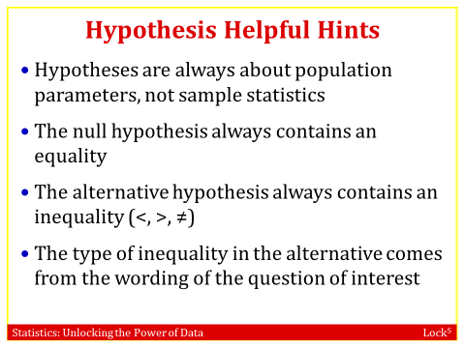
- The three possible forms for the hypotheses for a test for μ
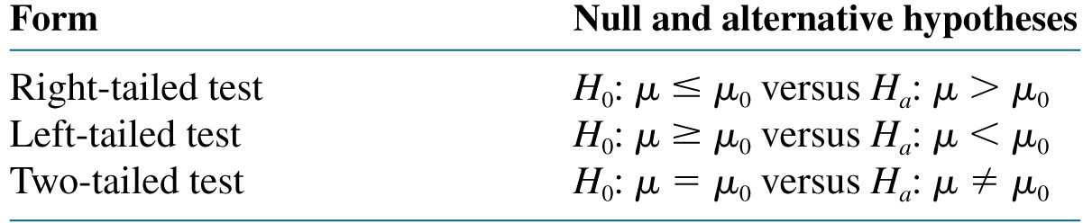

https://www.youtube.com/watch?v=_Qlxt0HmuOo (video for how to set up H₀ and H_{a} )
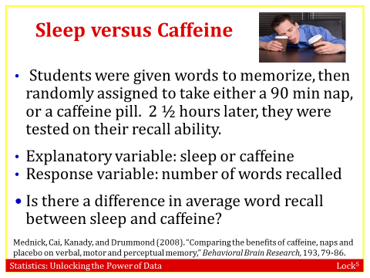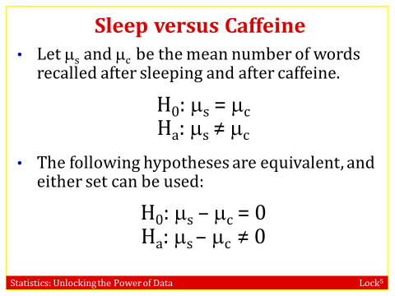
- The null hypothesis is a statement of no difference and always contains a statement of equality. The null hypothesis is assumed true until we have evidence to the contrary. We seek evidence that supports the statement in the alternative hypothesis
- Key words:
Difference, change, differ ≠
Less, more, decrease, increase < or >

Ex: According to a study published in March, 2006 the mean length of a phone call on a cellular telephone was 3.25 minutes. A researcher believes that the mean length of a call has increased since then.
H₀: μ = 3.25. H_{a}: μ > 3.25, a right-tailed test.

Write down the hypotheses for the test in each case below:
a). Does the proportion of people who support gun control differ between males and females?
p_{f}: proportion of females who support gun control
p_{m}: proportion of males who support gun control
H₀: p_{f} = p_{m} H_{a}: p_{f} ≠ p_{m}
b). Are the average hours of sleep per night for college students less than 7?
H₀: μ = 7 where μ is the average number of hours of sleep at night for college students
H_{a}: μ < 7 since we are looking for evidence that the mean is less than 7
Ex; State whether each set of hypotheses is valid for a statistical test.
(a) H₀: μ₁ ≠ μ₂ vs H_{a}: μ₁ = μ₂ Invalid
(b) H₀: p = 0.5 vs H_{a}: p > 0.5 Valid
(c) H₀: ₁ = ₂ vs H_{a}: ₁ < ₂ Invalid
(d) H₀: p₁ < p₂ vs H_{a}: p₁ > p₂ Invalid
4.2 : Measuring Evidence with p-values
In this section we are going to look at how to determine which outcome is appropriate. In other words, based on our observed statistic should we reject the null or fail to reject the null.

Our key question is …
How unusual is it to see a sample statistic as extreme as that observed, if H₀ is true?
If it is very unusual, we have statistically significant evidence against the null hypothesis.

To see if a statistic provides evidence against H_{0,} we need to see what kind of sample statistics we would observe, just by random chance, when the null hypothesis is true.

A randomization distribution is a collection of statistics from samples simulated assuming the null hypothesis is true. The randomization distribution shows what types of statistics would be observed, just by random chance, if the null hypothesis were true.

A randomization distribution simulates samples assuming the null hypothesis is true, so
A randomization distribution is centered at the value of the parameter given in the null hypothesis
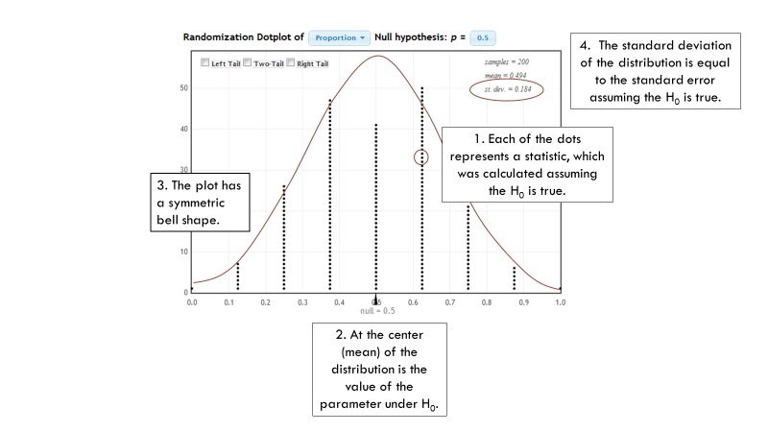
Does drinking tea boost your immune system?
- Explanatory variable: tea or coffee
- Response variable: immune system response
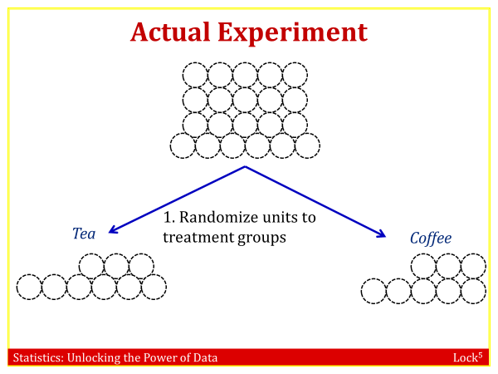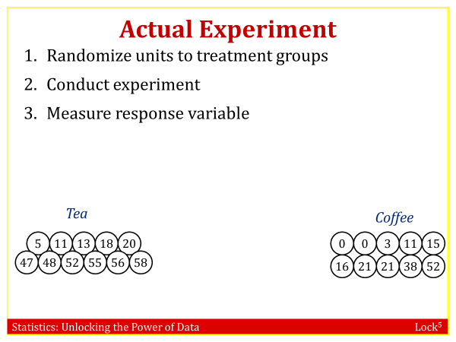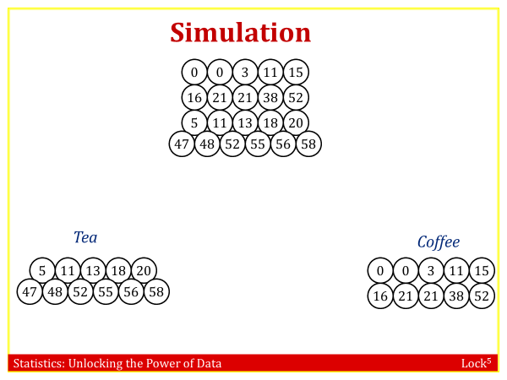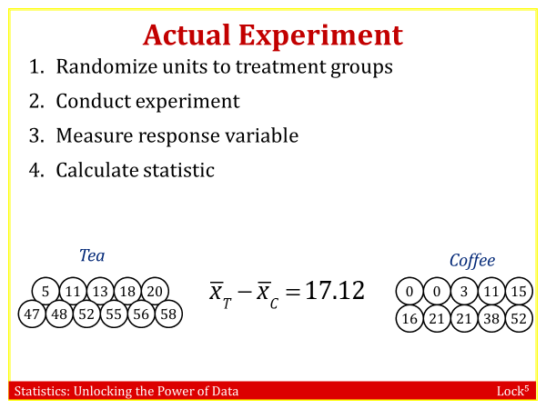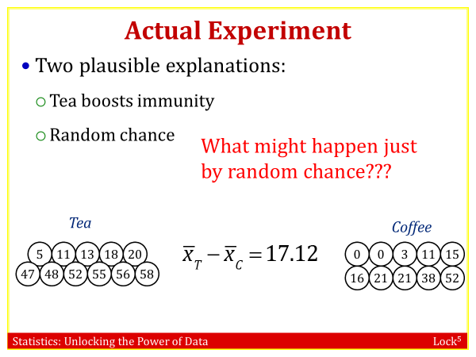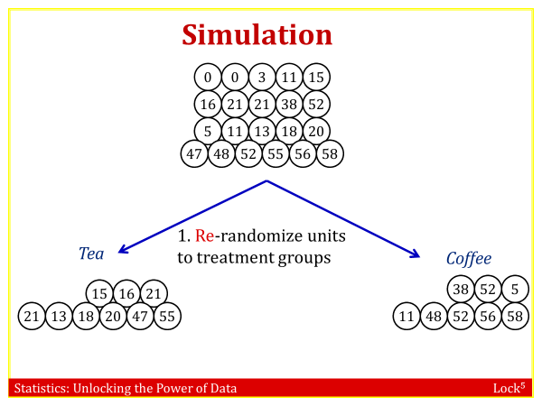
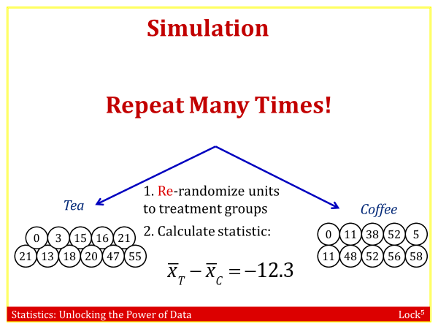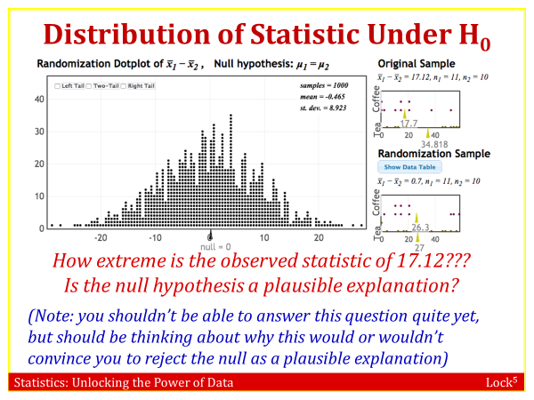
Randomization Test:
- State hypotheses
- Collect data
- Calculate statistic:
- Simulate statistics that could be observed, just by random chance, if the null hypothesis were true (create a randomization distribution)
- How extreme is the observed statistic? Is the null hypothesis (random chance) a plausible explanation?
The p-value is the chance of obtaining a sample statistic as extreme (or more extreme) than the observed sample statistic, if the null hypothesis is true.
When the p-value is low we reject H₀.
When the p-value is high we fail to reject H₀.
We measure the strength of evidence a sample shows against the null hypothesis with a p-value.

The p-value is the probability of obtaining a sample statistic as extreme as (or more extreme than) the observed sample statistic, when the null hypothesis is true
It describes how unusual the observed data would be if H₀ were true.
A small p-value means that the observed sample results would be unlikely to happen, when the null hypothesis is true, just by random chance.

The smaller the P-value, the stronger the evidence the data provide against the null hypothesis.
When making formal decisions based on the p-value, we use a pre-specified significance level, 𝛼.
• If p-value < 𝛼, we reject H0 and have statistically significant evidence for Ha.
• If p-value ≥ 𝛼, we do not reject H0, the test is inconclusive, and the results are not statistically significant.
One way to estimate a p-value is to construct a randomization distribution of sample statistics that we might see by random chance, if the null hypothesis were true.
The p-value is the proportion of randomization statistics that are as extreme as the observed sample statistic.
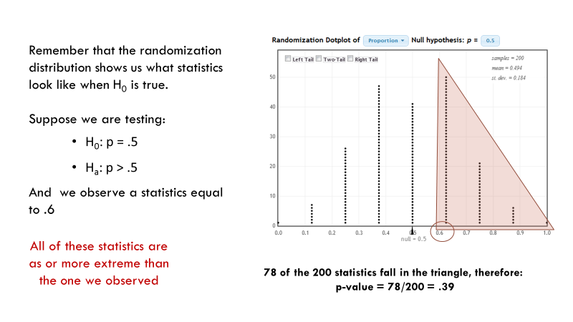
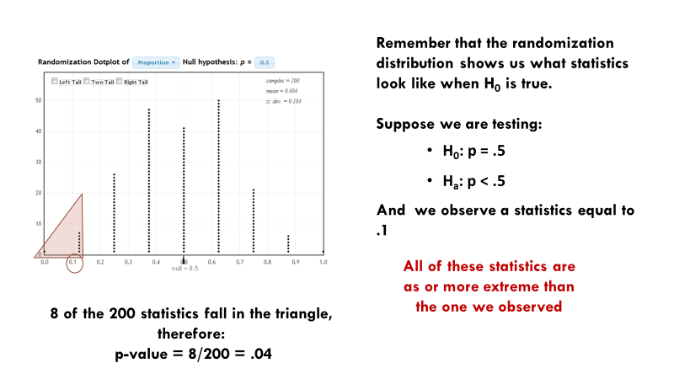
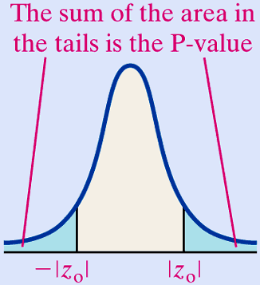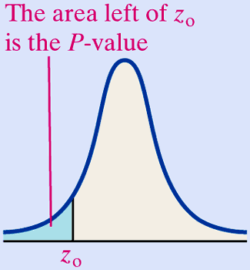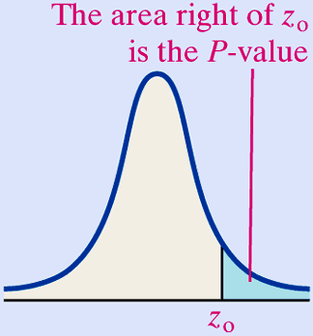
Two-tailed test left tailed test Right tailed test

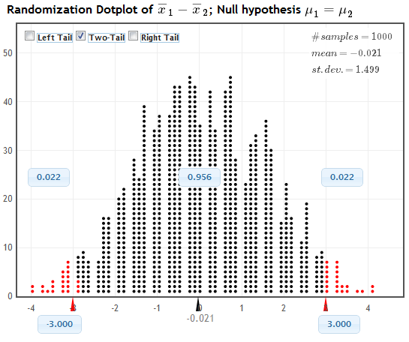
A randomization distribution for difference in mean memory recall between sleep and caffeine groups for data in SleepCaffeine is shown. Each dot is a difference in means that might be observed just by random assignment to treatment groups, if there were no difference in terms of mean (memory) response. The hypotheses are:
H₀: μ_{s} = μ_{c} vs H_{a}: μ_{s} ≠ μ_{c}.
The sample statistic is .
Use the randomization distribution to state the p-value.
We see that 0.022*2= 0.044 (because two tailed test)of the simulated statistics are as extreme as the observed statistic (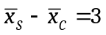), so the p-value is 0.044. This p-value is less than 0.05, so the results are statistically significant at 𝛼 = 0.05, giving moderately strong evidence that sleeping is better than drinking caffeine for memory.
Example: Support for the Death Penalty
In 1980 and again in 2010, a Gallup poll asked a random sample of 1000 US citizens” Are you in favor of the death penalty for a person convicted of murder?” In 1980, the proportion saying yes was 0.66. In 2010, it was 0.64. Does this data provide evidence that the proportion of US citizens favoring the death penalty was higher in 1980 than it was in 2010? Using p1 for the proportion in 1980 and p2 for the proportion in 2010:
(a) State the null and alternative hypotheses:
This is a difference in proportions test, with hypotheses H0 : p1 = p2 vs Ha : p1 > p2.
(b) What is the sample statistic?
The sample statistic is the difference in sample statistics: ˆp1 − ˆp2 = 0.66−0.64 = 0.02
(c) To create the randomization distribution, what do we have to assume?
To create the simulated statistics, we assume the proportions are equal, as stated in the null hypothesis.
(d) (Show a randomization distribution on StatKey or a slide and ask:) Which of the following is closest to the p-value? 0.001, 0.05, 0.20, 0.5
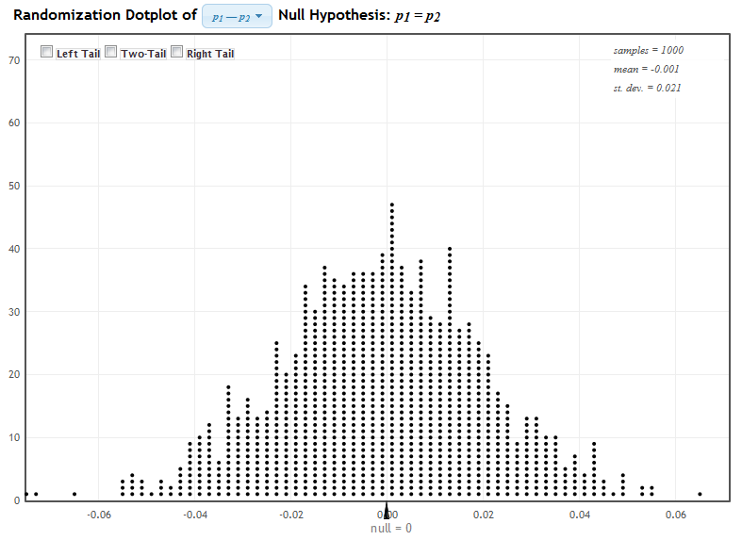

The p-value is the proportion of dots in the area indicated(right tailed test), which is closest to 0.20
Quick Self-Quiz: P-values from Randomization Distributions
To test H₀: μ = 50 vs H_{a}: μ < 50 using sample data with = 43.7:
Where will the randomization distribution be centered? Why?
At 50, since we must assume the null hypothesis is true when we create the randomization distribution.
Is this a left-tail test, a right-tail test, or a two-tail test?
It is a left-tail test, since the alternative hypothesis is μ < 50.
How can we find the p-value once we have the randomization distribution?
We see how extreme the sample statistic of 43.7 is in the left tail of the randomization distribution.

4.3. Determining Statistical Significance
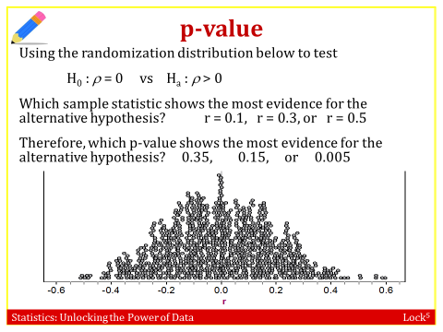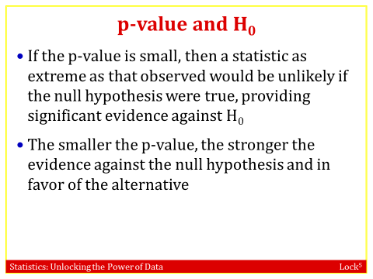
r = 0.5 shows the most evidence and p = 0.005 shows the most evidence. Idea to get across: Sample statistics far out in the tail show the most evidence against the null, so small p-values show the most evidence.

Quick Self-Quiz: Which P-value shows more evidence?
In each case, which p-value provides the strongest evidence against H₀ and for H_{a}?
a). p-value = 0.95 or p-value = 0.02

b). p-value = 0.008 or p-value = 0.02
The smaller the p-value, the stronger the evidence against H₀

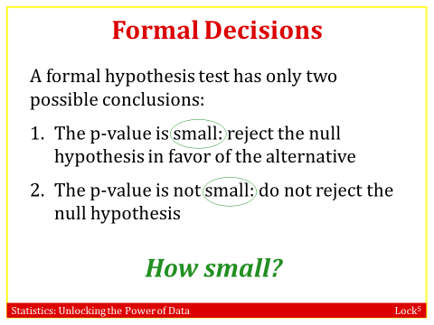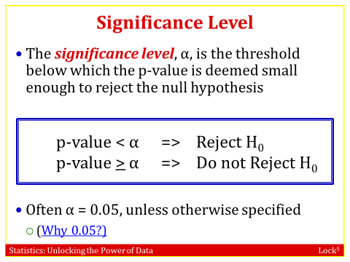

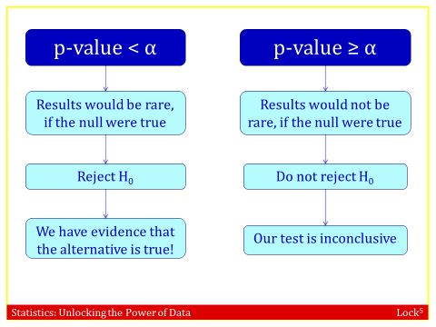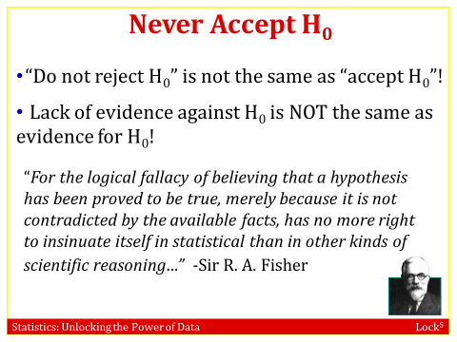
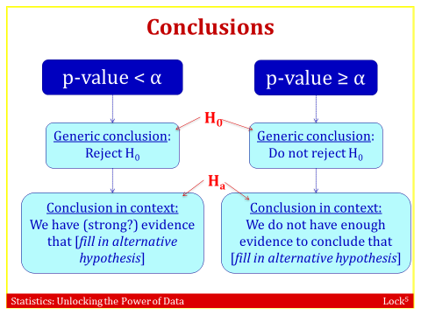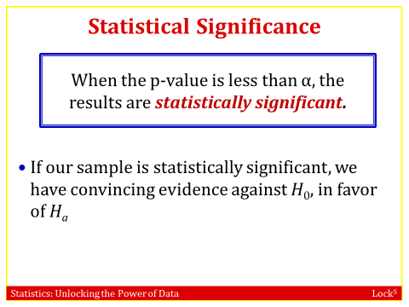
Example: Red Wine and Weight Loss
Resveratrol, an ingredient in red wine and grapes, has been shown to promote weight loss in animals. In one study, a sample of lemurs had various measurements taken before and after receiving resveratrol supplements for 4 weeks. For each p-value given, indicate the formal generic conclusion as well as a conclusion in context. Use a 5% significance level.
(a) In the test to see if the mean resting metabolic rate is higher after treatment, the p-value is 0.013. Reject H₀. There is evidence that metabolism is higher after receiving resveratrol.
(b) In the test to see if the mean body mass is lower after treatment, the p-value is 0.007.
Reject H₀: There is strong evidence that body mass is lower after receiving resveratrol.
(c) In the test to see if locomotor activity changes after treatment, the p-value is 0.980.
Do not reject H₀. The data does not provide any evidence that resveratrol affects activity level.
(d) In the test to see if mean food intake changes after treatment, the p-value is 0.035.
Reject H₀: There is evidence that food intake is different after treatment (receiving resveratrol).
(e) Which of the results given in (a) - (d) above are significant at a 1% level?
Only the result in (b) on body mass. That p-value of 0.007 is very small and is significant at the 1% level
Quick Self-Quiz: Making Conclusions
1. In a hypothesis test of H₀: μ = 18 vs H_{a}: μ > 18, we obtain a p-value of 0.016. Using α = 0.05, we conclude:

a). Reject H₀ b). Do not reject H₀ c). Reject H_{a} d). Do not reject H_{a}

Point out that options (c) and (d) are never viable options.

2. In a hypothesis test of H₀: μ = 18 vs H_{a}: μ > 18, we obtain a p-value of 0.016. Using α = 0.05, we conclude:

a). There is evidence that μ = 18 b). There is evidence that μ > 18 c). There is no evidence of anything

Point out that (a) is never a viable option.

Example 3: Sugar in Bottled Iced Tea
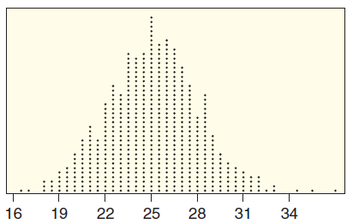
The nutrition label on a brand of iced tea says that the average amount of sugar per bottle is 25 grams. A chemical analysis of a sample of 30 bottles finds a mean of 33.8 grams of sugar per bottle. Test to see if this provides significant evidence that the true average is greater than 25. A randomization distribution for the test is shown, showing 1000 randomization statistics. [Show all details: state hypotheses, give notation and value of the sample statistic, use the randomization distribution to estimate the p-value, give a formal conclusion at a 5% level, and give a conclusion in context.]
H₀: μ = 25 where μ is mean grams of sugar for all bottles
H_{a}: μ > 25

Statistic: = 33.8

p-value is proportion of statistics to the right of 33.8, which appears to be 3/1000 = 0.003. We estimate p-value = 0.003.
(This is just an estimate, but students should know the p-value is small!)

Formal conclusion: Reject H₀

Conclusion in context: There is strong evidence that the mean number of grams of sugar in bottles of this iced tea is greater than 25 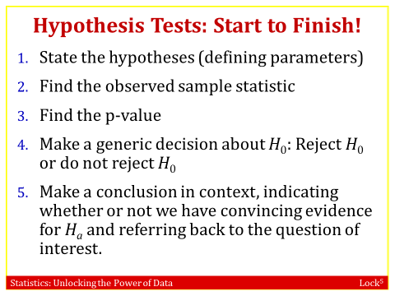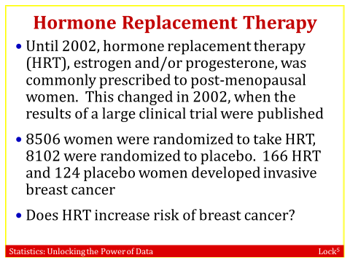
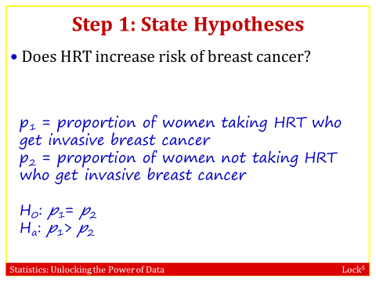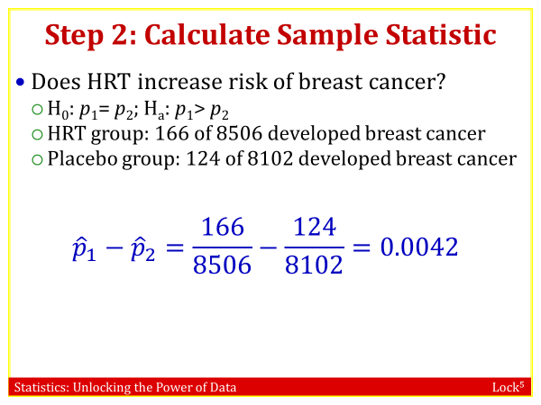
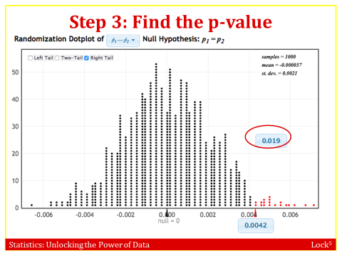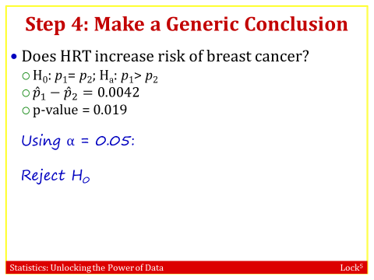
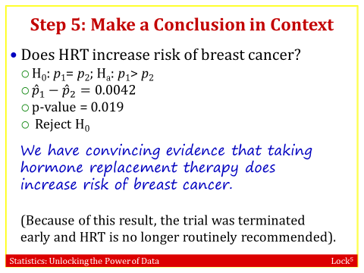

4.4: A Closer Look at Testing
- Statistics (unlike mathematics) is not an exact science! We will be wrong sometimes in a statistical test
- Conclusions based off p-values are not perfect
- Type I and Type II errors can happen

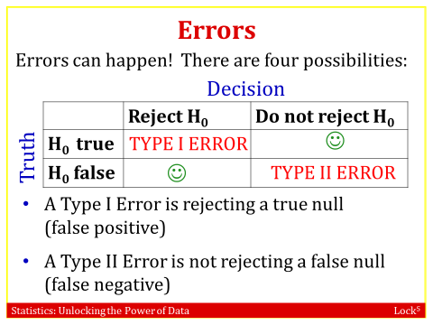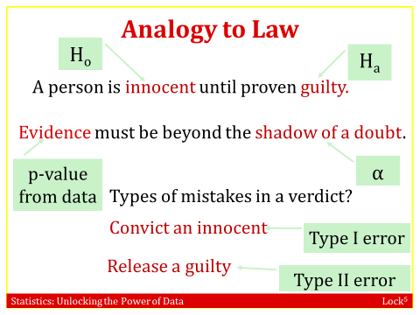
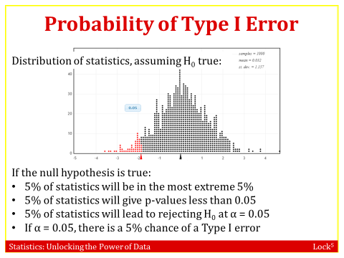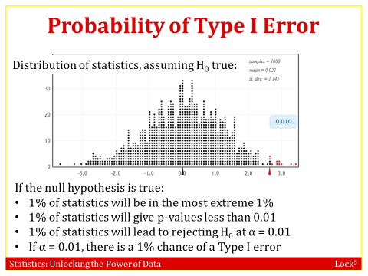
- The probability of making a Type I error (rejecting a true null) is the significance level, , α
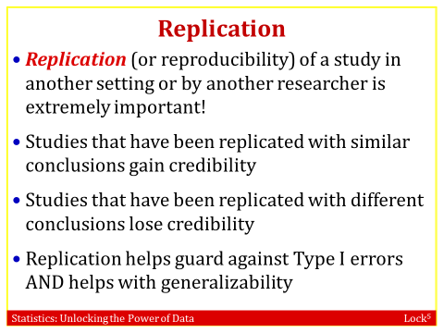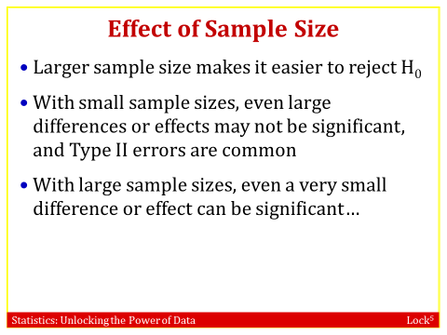
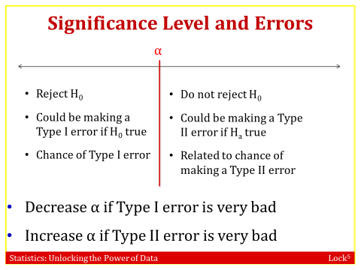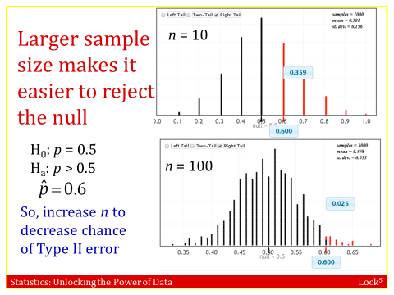
- If a Type I error (rejecting a true null) is much worse than a Type II error, In another words, if we don’t want to reject H_{0,} we may choose a smaller α, like α = 0.01
- If a Type II error (not rejecting a false null) is much worse than a Type I error, In another words, if we want to reject H_{0,} we may choose a larger α, like α = 0.10(or use a larger sample size).
Example : BPA in Tomato Soup
A consumer protection agency is testing a sample of cans of tomato soup from a company. If they find evidence that the average level of the chemical bisphenol A (BPA) in tomato soup from this company is greater than 100 ppb (parts per billion), they will recall all the soup and sue the company.

a). State the null and alternative hypotheses.
This is a test for a single mean. The hypotheses are H₀: μ = 100 vs H_{a}: μ > 100
b). what does a Type I error mean in this situation?
A Type I error means the company’s mean is within normal bounds of 100 (the null hypothesis is true) but the sample obtained happens to show(incorrectly) that the mean is too high and the agency ends up recalling all the soup and suing the company when it shouldn’t have.
c). what does a Type II error mean in this situation?
A Type II error means the company’s mean is too high (the null hypothesis is false) but the sample obtained doesn’t give sufficient evidence to show that it is too high and the agency (incorrectly) decides not to recall the soup or sue the company.
d). which is more serious, a Type I error or a Type II error?
(There is no right answer to this one. It is a matter of opinion and one could argue either way.)
Both seem pretty serious so you really want to try to not make an error. (Good time to remind them of the benefits of a larger sample size!)

Example : Vitamin E and Heart Attacks?
Suppose 100 tests are conducted to determine whether taking vitamin E increases one's chances of having a heart attack. Suppose also that vitamin E has absolutely no effect on one's likelihood of having a heart attack. The tests will use a 5% significance level.
- How many of the tests are likely to show significance, just by random chance?
5% of the 100 tests, or 0.05(100) = 5 tests
(Remember that the significance level gives the probability of making a Type 1 error, so about 5% of the 100 tests will make a Type I error. In this case, that means showing significance when there really is nothing significant.)

- If only the significant tests are reported, what is the only information the public is likely to hear?

The public will hear the false information that vitamin E causes heart attacks! Emphasize that all significant tests should be replicated in further tests before we are confident in the results.

Quick Self-Quiz: Experimenting with Sample Size on StatKey
Suppose that we are testing a coin to see if it is fair, so our hypotheses are H₀: p = 0.5 vs H_{a}: p ≠ 0.5. In each of (a) and (b) below, use the “Edit Data” option on StatKey to find the p-value for the sample results and give a conclusion in the test.
- We get 56 heads out of 100 tosses.

The p-value is about 0.28. An outcome of 56 heads in 100 tosses is relatively likely to happen by random chance, and we do not have evidence that the coin is not fair.

- We get 560 heads out of 1000 tosses.
The p-value is very small, close to zero. An outcome of 560 heads in 1000 tosses is very unlikely to happen just by random chance with a fair coin, so we have strong evidence that the coin is not fair.
- Compare the sample proportions in parts (a) and (b). Compare the p-values. Why are the p-values so different?
The sample proportions are the same, 0.56 in both (a) and (b).
The p-values are very different: 0.28 (not at all significant) to 0.000 (very significant!)
The difference is due to the sample size. Sample size is very important in statistics, and a larger sample size can help us find significant results, such as a biased coin, if the coin really is biased.

4.5: Making Connections
In Chapter 3 we examine methods to construct confidence intervals for population parameters. We sample (with replacement) from the original sample to create a bootstrap distribution of possible values for a sample statistic. Based on this distribution, we produce a range of plausible values for the parameter so that we have some degree of certainty that the interval will capture the actual parameter value for the population.
In this chapter, we develop methods to test claims about populations. After specifying null and alternative hypotheses, we assess the evidence in a sample by constructing a randomization distribution of possible sample statistics that we might see by random chance, if the null hypothesis were true. If the original sample statistic falls in an unlikely location of the randomization distribution, we have evidence to reject the null hypothesis in favor of the alternative.
In Chapter 3, we see that a confidence interval shows us the plausible values of the population parameter. In Chapter 4, we use a hypothesis test to determine whether a given parameter in a null hypothesis is plausible or not. Thus, we can use a confidence interval to make a decision in a hypothesis test, and we can use a hypothesis test to determine whether a given value will be inside a confidence interval!
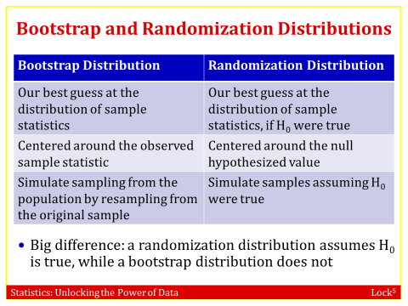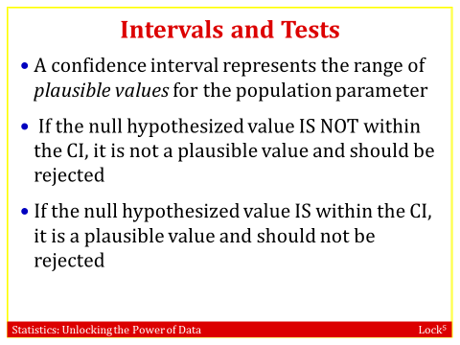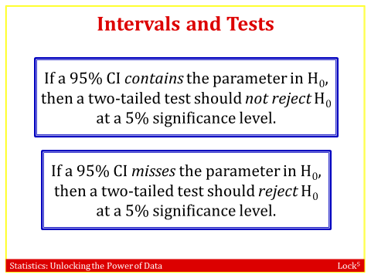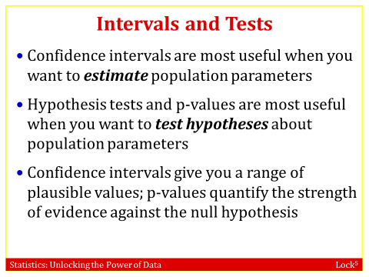

Example 1: Normal Human Body Temperature
We find a 95% confidence interval for mean body temperature μ to be 98.05 to 98.47. What is the conclusion of a test of H₀: μ = 98.6 vs H_{a}: μ ≠ 98.6$? What significance level is used in making the conclusion?
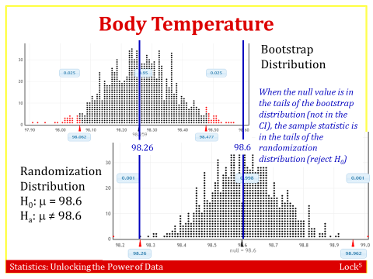
The value 98.6 is not inside the confidence interval, so 98.6 is not a plausible value for μ and we reject H₀. There is evidence that mean body temperature is not 98.6°F. The significance level used is 5%, since the confidence level used was 95% for the interval.
Example 2: Happy Family?
The Pew Research Center asked a random sample of US adults age 18 to 29 ``Does a child need both a father and a mother to grow up happily?” A 95% confidence interval is given below for p, the proportion of all US adults age 18 to 29 who say yes. Use the interval to state the conclusion to a hypothesis test of H₀: p = 0.5 vs H_{a}: p ≠ 0.5.
- In 2010, the 95% confidence interval was 0.487 to 0.573.
Since 0.5 is in the confidence interval 0.487 to 0.573, and thus is a plausible value for p, we do not have evidence against the null hypothesis so we do not reject H₀. At a 5% level, we do not have evidence in 2010 that the proportion is different from 0.5.
- In 1997, the 95% confidence interval was 0.533 to 0.607.
Since 0.5 is not in the confidence interval 0.533 to 0.607, and thus is not a plausible value for p, we do have evidence against the null hypothesis, so we reject H₀. At a 5% level, we have evidence that the proportion in 1997 is different from 0.5.

Quick Self-Quiz: Intervals and Tests
Using the confidence interval given, indicate the conclusion of the test and indicate the significance level used.
- A 95% confidence interval for a mean μ is 12.5 to 17.1. Testing H₀: μ = 18 vs H_{a}: μ ≠ 18.
18 is outside the interval so is not a plausible value for μ so we reject H₀ at a 5% level.

- A 90% confidence interval for a proportion p is 0.62 to 0.80. Testing H₀: p = 0.65 vs H_{a}: p ≠ 0.65.
0.65 in inside the interval so is a plausible value for p so we do not reject H₀ at a 10% level.
- A 99% confidence interval for a difference in proportions is – 0.10 to 0.20. Testing H₀: p₁ = p₂ vs H_{a}: p₁ ≠ p₂.
A difference of 0 (no difference in proportions) is inside the interval, so is a plausible value for p₁ – p₂ so we do not reject H₀ at a 1% level.
Example 3: Normal Human Body Temperature, Revisited
Normal human body temperature is generally considered to be 98.6°F. We wish to test to see if there is evidence that mean body temperature is different from 98.6°F. We collect data from a random sample of 50 people and find = 98.26.

a). State the null and alternative hypotheses.
H₀: μ = 98.6 vs H_{a}: μ ≠ 98.6

b). Use StatKey to create a randomization distribution for this test, and then use it to find the p-value. Use the p-value to make a conclusion in the test.

Notice that the distribution is centered at 98.6 as it should be. We see how extreme the sample statistic of 98.26 is in the tail of the randomization distribution and we remember to double it since this is a two-tail test. We see that the p-value is very small, so even doubling it, we still get a p-value very close to zero. There is very strong evidence that average human body temperature is not 98.6°F.

Example 4: Evaluating Drugs to Fight Cocaine Addiction
In a randomized experiment on treating cocaine addiction, 48 cocaine addicts who were trying to quit were randomly assigned to take either desipramine (a new drug), or Lithium (an existing drug). The response variable is whether or not the person relapsed (which means the person was unable to break out of the cycle of addiction and returned to using cocaine.) We are testing to see if desipramine is better than lithium at treating cocaine addiction. The results are shown in the two-way table.

 | Relapse | No relapse | Total
Desipramine | 10 | 14 | 24
Lithium | 18 | 6 | 24
Total | 28 | 20 | 48

- Using p_{D} for the proportion of desipramine users who relapse and p_{L} for the proportion of lithium users who relapse, write the null and alternative hypotheses. [Example continued on reverse.]
H₀: p_{D} = p_{L} vs H_{a}: p_{D} < p_{L}

- Compute the appropriate sample statistic.
We see that and so we have

- We compute a randomization statistic by assuming the null hypothesis is true. What does that mean in this case?
It means that the two proportions are equal and the drug has no effect on the relapse rate. It doesn’t matter what drug is taken.

- How might we compute a randomization sample for this data? What statistic would we compute as the randomization statistic?
Since drug doesn’t matter, we combine all 48 patients together and see that 28 relapsed and 20 didn’t. To see what happens by random chance, we randomly divide them into two groups and compute the difference in proportions of relapses between the two groups. The difference in proportions is the statistic.

- We can use StatKey to generate a randomization dotplot for the difference in proportions based on this sample and what we might see by random chance of the null hypothesis is true. Describe the resulting distribution. Where is it centered?
The resulting distribution will be bell-shaped and centered at the null hypothesis value, which is zero.

- How extreme is the sample statistic from part (b) in the randomization distribution? This tells us how unlikely the sample data is if the null hypothesis is true (which is the p-value!) Use the sample statistic calculated in (b) to find the p-value for this test. Use the p-value to make a conclusion.

This is a left-tail test, and we see on StatKey that the p-value is about 0.016. We reject the null hypothesis and conclude that despramine is significantly better at helping people kick the cocaine habit.

